**Game 7: Puzzled by Projection I**

**Why?**

Projection is key to medical imaging technologies like X-ray, CT, and MRI. Each projection is a point of view that gives us a “shadow” of a higher-dimensional object. These “shadows” contain partial information, which can be combined to recover the original object in all its glory - for example, the inner structures of you!

**Materials**

* 3 letters phantoms (N, Y, C)
* 9 of basic shape phantoms (triangle, square, star)
* 3 of set 1 projection phantoms (half circles with central slit)

**Key Terms**

1. 3D coordinates
2. 2D projection
3. 1D projection
4. Projection imaging

**Background**

1. **3D coordinates**

Any point in 3D space can be located with a 3D vector (x,y,z), which denotes its position relative to a known origin point. A 3D model is defined by surfaces, which are defined by triangles, which are in turn defined by its three vertices, each of which has coordinates (xi,yi,zi).

1. **2D projections** are easy to visualize. Imagine a brick suspended in air in a room with a top light that emits parallel rays:



The brick casts a rectangular, uniform shadow. Now, if we drill holes in the brick, they are going to pass light and change the shape of the shadow. If we start playing with different geometrical shapes, all of them will have shadows of different shapes and sizes.

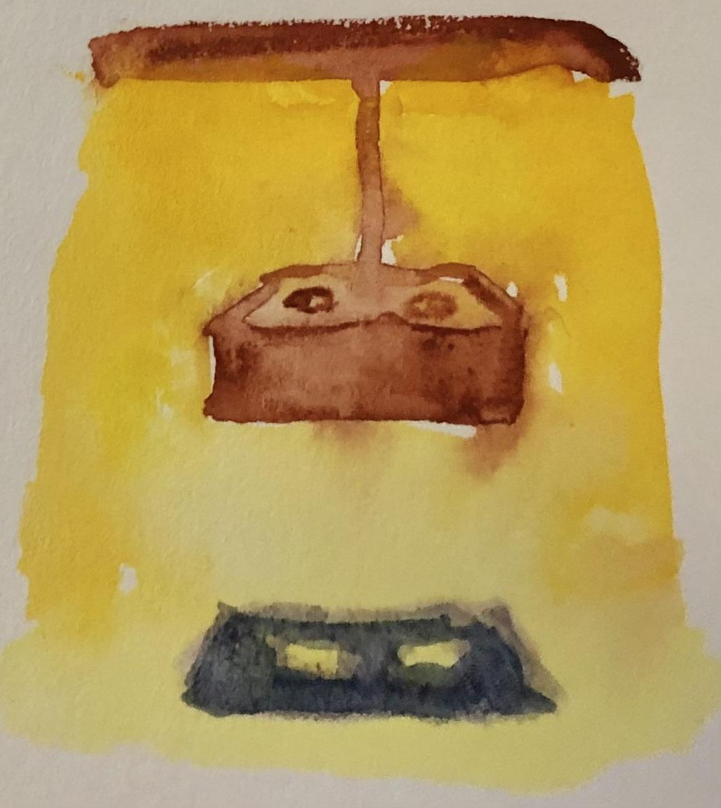

if we change the brick into a translucent block of glass, the shadow will be lighter, as more light comes through:



Real world objects (such as your brain) are made of different materials at different spots. Therefore, when light passes through them, the amount that reaches the other side varies and creates a weirdly shaded shadow. In this case, we are talking about quite high-energy light: X-rays! This is exactly how plain X-rays work!

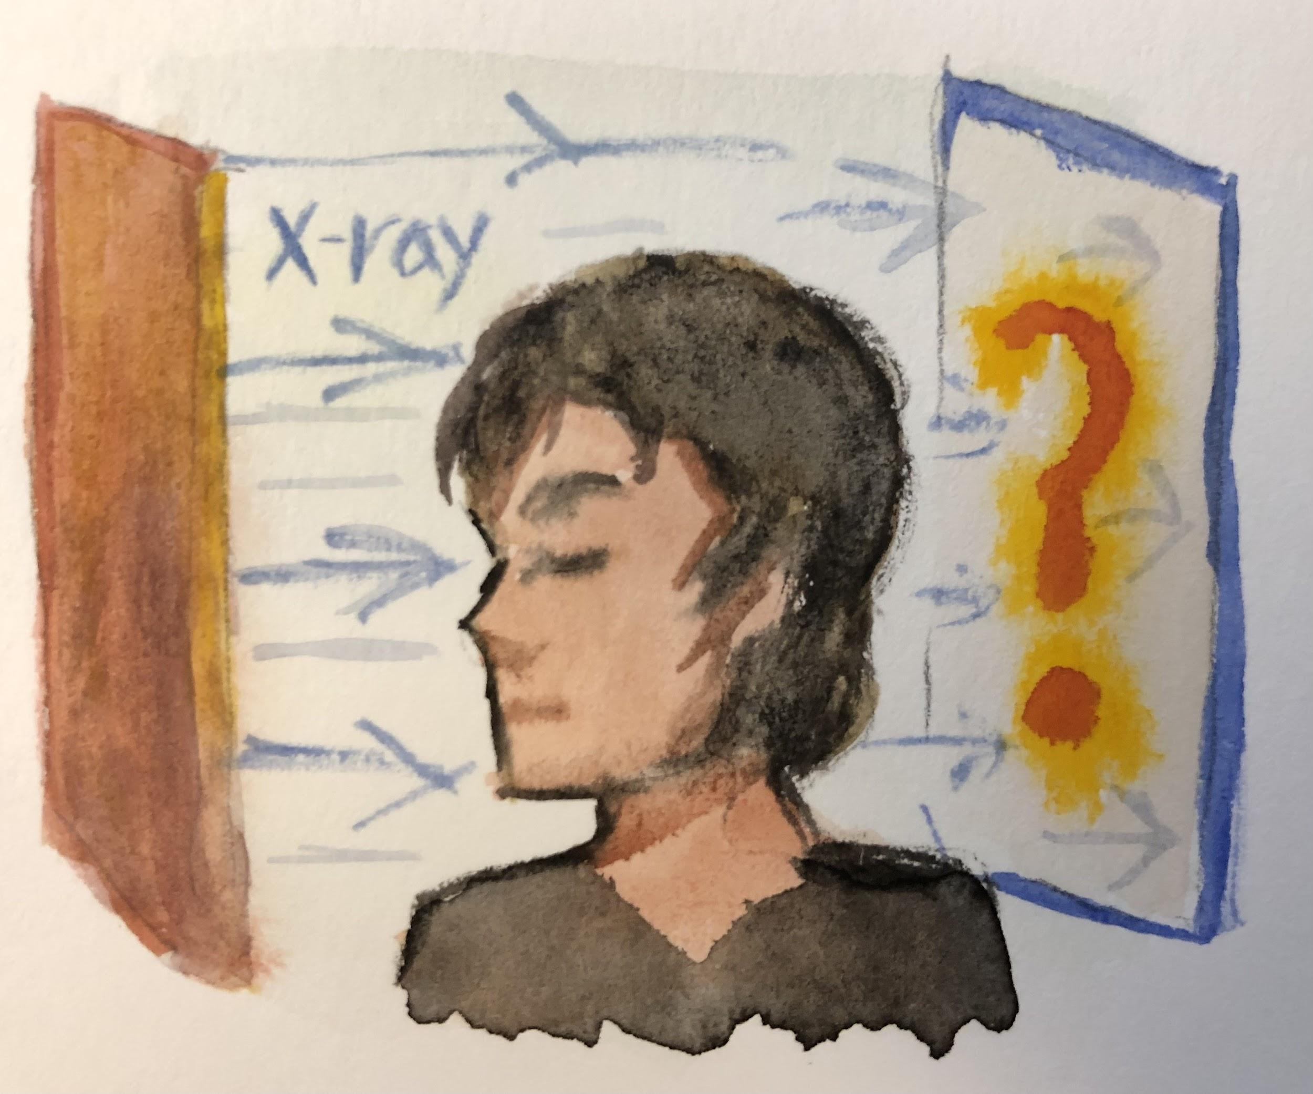

In this case, we see more light coming out the other side when there is less material for it to pass through. The amount of light can be measured on a light-sensitive sheet. Then the total amount of material the light had to pass through can be calculated for each point on the shadow. Brighter parts mean there was more material, and darker parts mean there was less. This is our 2D projection!

More mathematically, a 2D projection of a 3D function along an axis can be calculated by summing up the function f(x,y,z) across all values on that axis. For example, a projection along the z axis can be calculated by creating a function g(x,y), where:

g(x0,y0) = (sum of f(x0,y0,z) for all z between negative infinity and positive infinity)

If you’ve taken calculus, you know this can be done with an integral for continuous functions.

In the game, you’ll be able to perform 2D projections along the x, y, and z axes.

1. **1D projections** turn 2D images into 1D curves just like 2D projections turn 3D volumes into 2D images. We can choose any angle from 0 degrees to 180 degrees to make the projection.

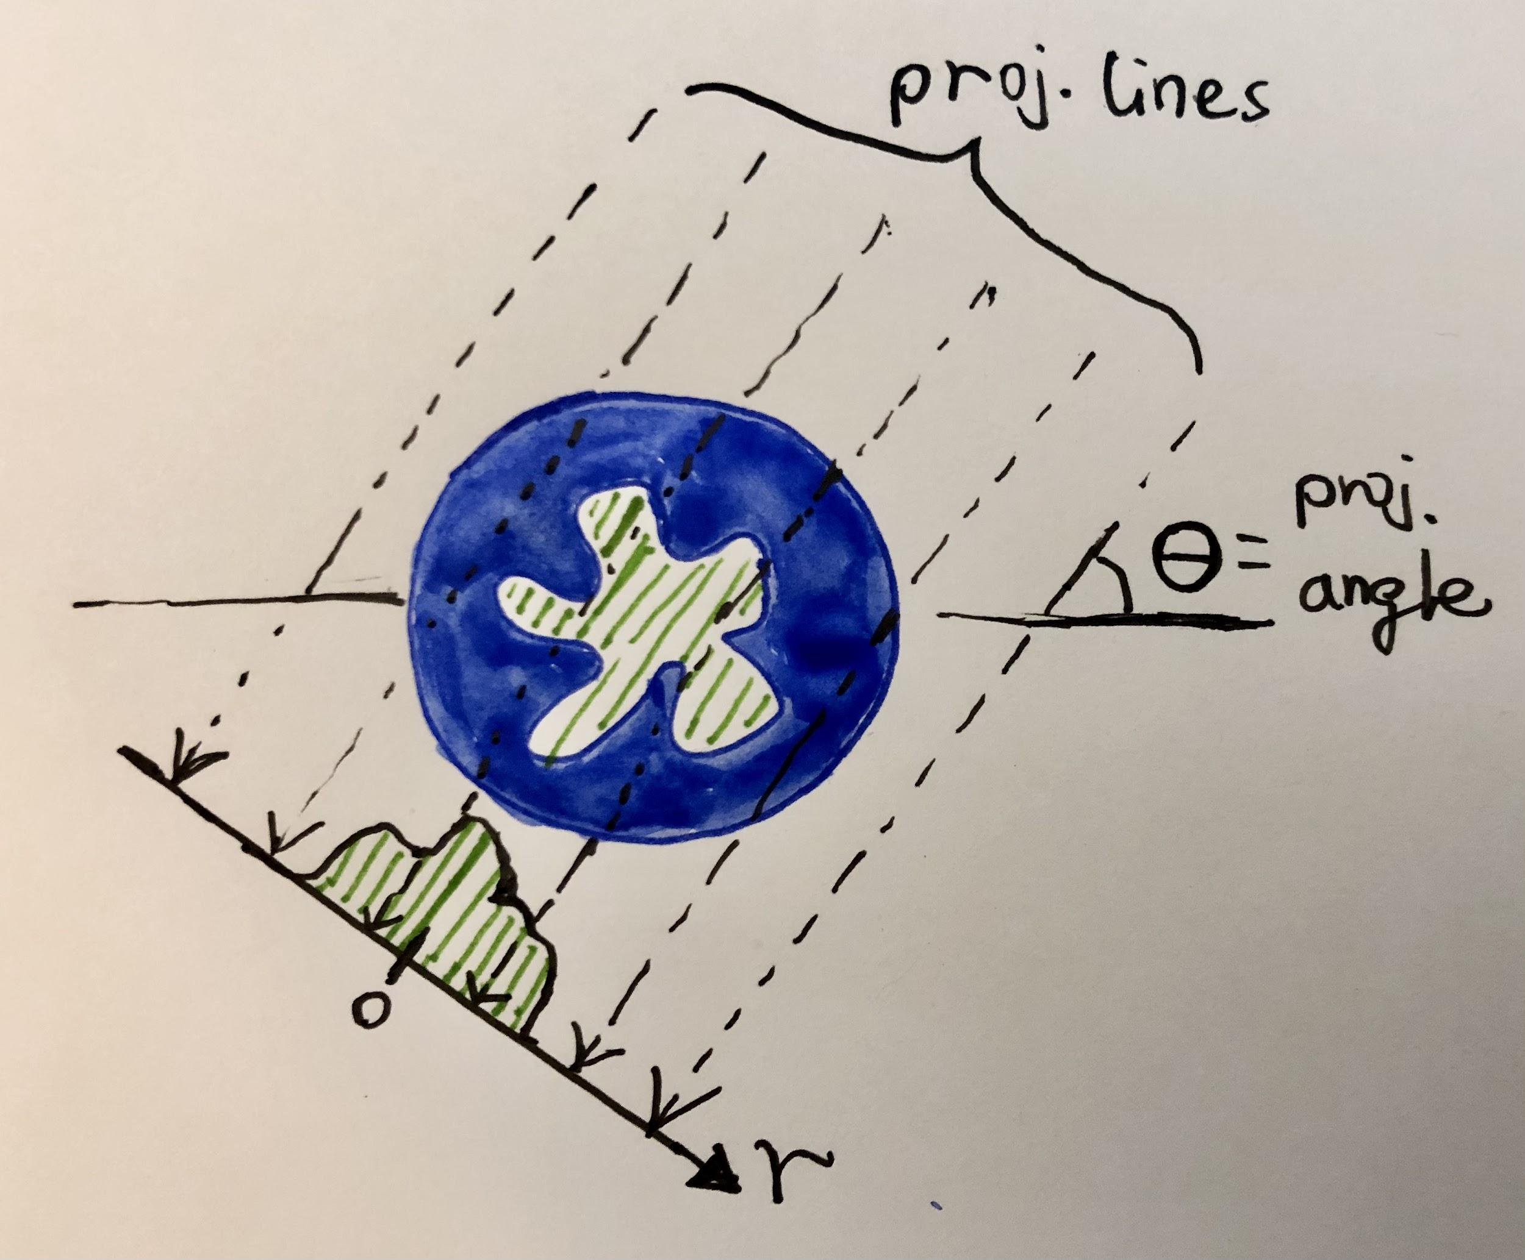

1. **Projection Imaging** works by making projections of the same subject and combining them to make images that show its internal structure. Examples include:

* Plain radiograph or X-ray: uses X-rays to obtain a single 2D projection on X-ray-sensitive film or digital screen and views it directly as the image. In a chest X-ray, there is no front to back information and things overlap with each other.
* Computed Tomography (CT): uses a rotating thin blade of X-ray to obtain many 2D-to-1D projections around a certain slice of your body (for example, around your waist or feet). These projections are combined, or reconstructed, to a single slice that shows clear internal structure and no overlap.
* Projection reconstruction in MRI: certain types of MRI data can be reconstructed using CT-like methods. Why this is the case involves spatially varying magnetic fields and how hydrogen in your body responds to them as well as mathematical relationships between projections and spatial frequencies.

**Lab procedures**

1. Explore 3D models

* Select one of the 3D models on the left panel and hit “load 3D model”.
* Rotate the model around and use the “transparent” button to observe its inner structures.
* Repeat this with other models and view them from different angles.

Can you know for sure about the model’s 3D shape if you’ve only viewed it from one angle?

1. Explore 3D to 2D projection

* Select “z” for the projection axis and hit “show/hide lines” to display the direction of our 3D to 2D projection;
* Hit “2D projection” to display the projected image. What do you see?
* Make the 3D model transparent. Rotate the 3D model so that the projection lines are pointing out of the screen. Compare this view to the 2D projection.
* Repeat 1-3 for “x” and “y” for a few models.

In your words, what is 2D projection? If you can take one 2D projection of yourself, how would you do it and what information will the image tell you? This is exactly what X-ray machines do!

1. Explore 2D to 1D projection

* Generate a 2D projection of the 3D model “N” in the “z” direction
* Use the circle controller to select a projection angle of 90 degrees
* Press “1D projection” to generate a 1D plot. You should see two bumps corresponding to the two legs of the letter “N”.
* Repeat with a projection angle of 0 degree. You should see a more flat curve. Because we are looking at “N” from the side, we can no longer tell the two legs apart.
* Explore projection at various angles for the different phantoms.

If we do enough 1D projections at various angles, we can figure out what the image looks like! This is how Computed Tomography or CAT scans work. Each new angle gives us a bit more information about the 2D slice. Some types of MRI also make images in this way.

1. Puzzle time!

Now it’s time for you to suss out some projections! Press “generate random model” to display some special cylinders and choose your favorite one. Don’t generate the 2D and 1D projections until you have completed the table!

Sketch these projections for the model:

| Model name: _______________ | | | | | | |
| --- | --- | --- | --- | --- | --- | --- |
| 3D to 2D | Axis: x | | Axis: y | | Axis: z | |
| 2D to 1D | Angle: 90 degrees | | Angle: 90 degrees | | Angle: 90 degrees | |
| Angle: 0 degree | | Angle: 0 degree | | Angle: 0 degree | |

Now you can press the projection buttons to check your answers. Do they make sense?

**Questions**

1. How many numbers are needed to locate a point in 3D space?
2. 9
3. 3
4. 42
5. 2
6. What of the following is true when you perform a 2D projection of a perfect 3D sphere?
7. The projection will have the same gray value across the image
8. The projection lines will bend to conform to the circular shape
9. The projection will be the same from any angle
10. The projection will be the same only when it’s pointing along the x, y, or z axis.

3. What happens when you perform a 1D projection of a rectangle?

1. The left, right, top, and bottom views are going to be the same
2. The left/right views are the same, and the top/bottom views are the same
3. The projection is always going to have right-angled corners
4. The projection depends on how the rectangle is oriented in the x-y plane

3. Which is the 2D projection of this 3D model (projection axis: z)?

A

B

C

D

4. Which is the 2D projection of this 3D model (projection axis: y)?

A

B

C

D

5. Which is the 2D projection of this 3D model (projection axis: x)?

A

B

C

D

6. What is the 1D projection of this 2D image?

7. What is the 1D projection of this 2D image?

8. What is the 1D projection of this 2D image?

9. What is the 1D projection of this 2D image?

10. What is the 1D projection of this 2D image?